**PCB REPORT – LAB 11 and 12**



**Measure trace resistance and blow-up traces**

**Objective:**

In this lab, we tried to measure the trace resistance of different sized traces ranging from 6mil, 10mil, 20mil and 100mil. We will make the measurements with a 2-wire and 4 wire method and try to find these measurements accuracy. In the subsiding lab will try to find the maximum current that trace can carry in safer conditions and what could be the maximum to blow up the traces.   
  
Resistance Measuring methods:

2-wire: In this method, usually DMM’s are used to measure resistance, where probe the component to measure its resistance. The current is passed through component via probes and measure the voltage drop across the component. Using Ohm’s law to it shows the resistance. This is prone to inaccuracy, because the resistance value is from both component and the probe wire itself.

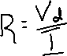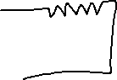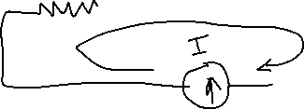

4-wire (Kelvin 4-wire): In this method the probes from DMMs are attached across component. Also, we connect the constant current source to the two ends of the component. Here the resistance from the probes connected is not considered, because the high impedance at the DMM’s end doesn’t allow the current to flow through the probes connected across the component. This allows us to read the correct voltage drop across the component and enables us to measure only the components resistance. This method is very useful in measuring the resistance value less than 0.1Ω.



*The formula denoted may be not correct but shown for simplicity.*

**Board:**

*Figure 1.1 Board with different width traces*

**Calculation:**  
The resistance of the trace is given by R = ꝭ * length/ Area, where ꝭ is resistivity of the material of the trace. The formula can also be described as R = ꝭ * length/ (thickness* width), where Area is constituted from thickness and width of the trace. Further length/ width can be defined by ⴄ, It says that the trace is made of these many number of pieces. ꝭ/thickness can be defined as Rsquare, it defines that the resistivity with respect to thickness of the trace.

Finally, R = Rsquare * ⴄ.  
  
Let’s calculate the resistance of the trace for different width traces, were Rsquare = 0.5mΩ/square:

6 mil:

ⴄ = 1 inch/0.006inch = 166.66 R = 83.3mΩ

10 mil:

ⴄ = 1 inch/0.01inch = 100 R = 50 mΩ

20 mil:

ⴄ = 1 inch/0.02inch = 50 R = 25 mΩ

100 mil:

ⴄ = 1 inch/0.1inch = 10 R = 5 mΩ

**Observation:**  
Noted the values read from the DMM for each trace:

|  |  |  |  |
| --- | --- | --- | --- |
| Line width | Estimated (in mΩ) | 2-wire (in mΩ) | 4-wire with 1 A current (in mΩ) |
| 6 mil | 83.3 | 130 | 63 |
| 10 mil | 50 | 100 | 36.5 |
| 20 mil | 25 | 80 | 18 |
| 100 mil | 5 | 70 | 3.82 |

Table 1.1 Reading for each trace from DMM.

Using 4 wire method the resistance is calculated as Rtrace = Vmeasure /Ithrough, where Ithrough = 1A.

6 mil:

Vmeasure = 62.96mV, Rtrace = 63 mΩ

10 mil:

Vmeasure = 36.5mV, Rtrace = 36.5 mΩ

20 mil:

Vmeasure = 18mV, Rtrace = 18 mΩ

100 mil:

Vmeasure = 3.82mV, Rtrace = 3.82 mΩ

**Conclusion:**

* From the above table, we can clearly say that the resistance measured using 4-wire is closer and lesser compared to the estimated one.
* The resistance measured using 2-wire is 50mΩ off due to additional resistance from probe leads and wire connecting to the DMM.
* So, we can conclude that 4 wire method preferable to measure the resistance less than 0.1 mΩ.

**Board with Blown-up traces:**



*Figure 1.2 Board from blown-up traces*

**Observations:**

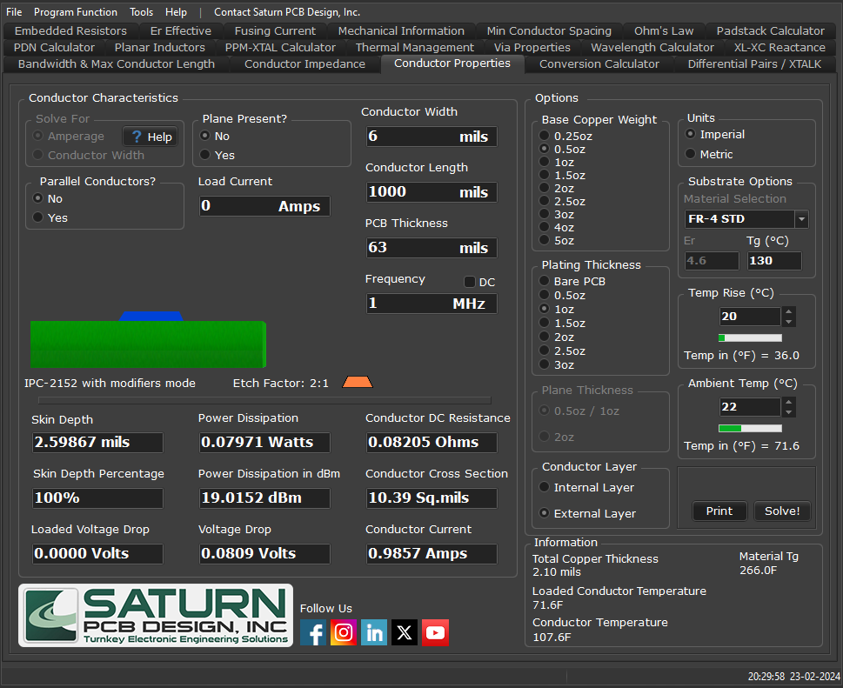  
Saturn software shows that estimated maximum current susceptible for 6mil trace should be 0.9857A.



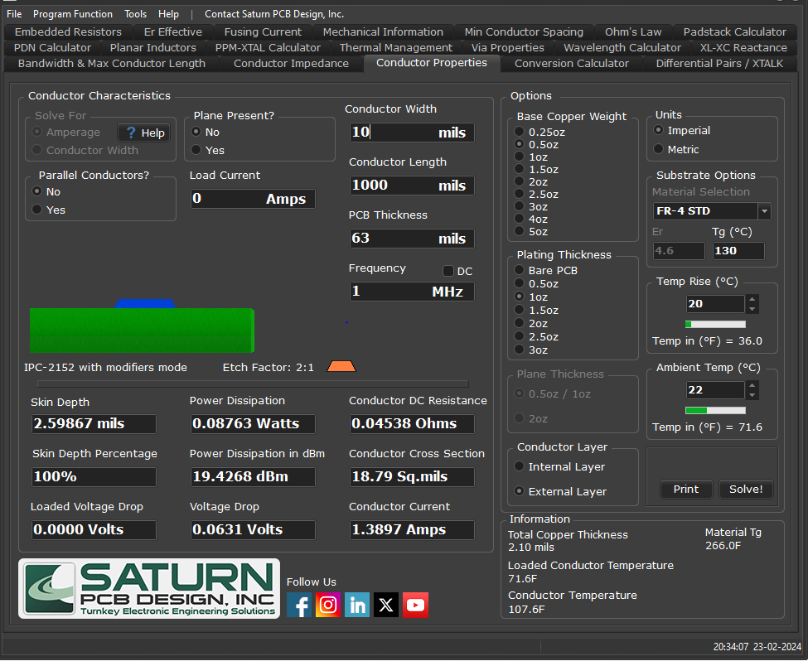



Furthermore, the maximum current susceptible for 10mil trace should be 1.3897A.

|  |  |  |  |
| --- | --- | --- | --- |
| Trace width | Safety current limit | Current reading when board trace to heat up (40 Celsius) | Current reading when board trace blow-up |
| 6 mil | 0.9857A | 2.5A(100mV) | 4.280A(700mV) |
| 10mil | 1.3897A | 2.5A(105mV) | 6A(500mV) |

Table 1.2 Current applied at certain stages of the experiment.

From the above table we can see the safety current measurement for 6 and 10mil. Also observed the current reading measured at the stages board trace started heating up and blown out. During this tested the relation between temperature and resistance and voltage drop across the trace, where resistance increases with temperature, so do the voltage drop.  
  
**Conclusion:**

* To avoid trace damage, we should follow strict current limit according to trace width, because incorrect estimate and design can lead to damage of trace and other components on the board.

**Key learnings:**  
1. Trace also has minute resistance, which depends on material and width of trace.

2. Importance of 4-wire method in finding resistance less than 0.1ohm.

3. Importance of trace width, current limit consideration while designing the board and its trace to work in ideal conditions such as negligible resistance.